UNIT 4 PLACES
OUTLINE

1 Language Development
1.1 The imperative
1.2 Noun phrases with of
1.3 Grammar for writing:
- there is / there are
- Determiners: articles
2 Vocabulary
2.1 Vocabulary for places
2.2 Prepositions of place
3 Critical thinking
3.1 Interpret maps and give directions
3.2 Order writing by topic
3.3 Classify words
3.4 Think of key words
4 Input
4.1 Listening
4.1.1 Listening for detail
4.1.2 Understanding key vocabulary
4.1.3 Using your knowledge
4.1.4 Listening for main ideas
4.2 Reading
4.2.1 Reading for main ideas
4.2.2 Understanding key vocabulary
4.2.3 Previewing
4.2.4 Scanning to find information
4.2.5 Reading for detail
5 Output
5.1 Speaking task:
Ask for and give directions
5.2 Academic writing skills:
Spelling and punctuation: capital letters
5.3 Writing task:
Write facts about your country

EXERCISES

1 Listen to Lisa give directions to Afet. Then write the order of the directions.

_5__ Go through the park.
__3_ Walk along South Street.
__6_ Go through the park.

_1__ Take the number six bus.
_2__ Turn left at Green Bridge.
_4__ Turn left at the supermarket.

2. Complete the sentences with the prepositions in the box
between at opposite in on
in front of behind next to

- Chen is ______at______ the bus stop.
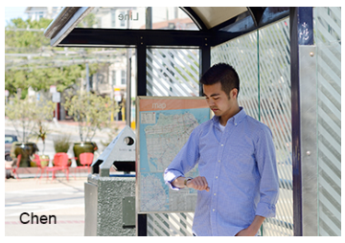

- Hana is _____behind_______ Mina.
Mina is _____in front of_______ Hana.


- Aki is _____next to_______ Hiro.
Hiro is _____between_______ Aki and Nobu.
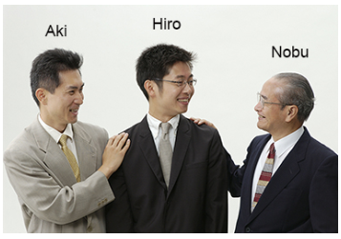

- Joe is ______in______ the library.
Joe is _____opposite_______ Kay.
Their laptops are ______on______ the table.


3. Read the sentences (1–8) below:
a. Put a tick if they are correct and a cross if they are wrong.
b. Correct the wrong sentences.

- There are many kinds of bread in Russia.
√
2) There is a deserts in Egypt.
× There is a desert in Egypt.
3) There is many parks in London.
× There are many parks in London.
4) In Thailand, there are many islands.
√
5) There have many people in Jakarta.
× There are many people in Jakarta.
6) There are in Istanbul many bridges.
× There are many bridges in Istanbul.
7) They are many famous monuments in Rome.
√
8) Is a famous museum in my city.
× there Is a famous museum in my city.

4. Read the sentences (1–8) below:
a. Put a tick if they are correct and a cross if they are wrong.
b. Correct the wrong sentences.

1) I come from the India.
√
2) The Paris is popular with tourists.
√
3) There are many tall buildings in the Abu Dhabi.
√
4) There are 3 million people in the Nagoya in the Japan.
√
5) United Kingdom is in the Europe.
× The United Kingdom is in the Europe.
6) Many people live in the Cairo.
√
7) Ural mountains are in Russia.
× The Ural mountains are in Russia.

5. Writing task: write facts about your country.
1) Put the topics in the box in a logical order. Write them in column A of the table below.
language currency population religion food
capital city industry climate full name geography

- Think of key words for your country. Write the key words for each topic in column B of the table below.
A  the topic | B  key words for the topic
1full name | China
2capital city | Beijing
3language | Chinese
4currency | RMB
5population | 1.4 Billion
6religion | Taoism
7food | Rice Flour
8geography | Asia
9climate | Monsoon
10industry | manufacturing

- Based on the table that you have created, write two sentences for each topic. Use the key words to help you.
Sample answers:
The capital of my country is Bangkok. There is a famous museum in Bangkok called the National Museum.
The population of Thailand is 70,000,000. There are many young people in my country.

- Use the task checklist to review your sentences.
TASK CHECKLIST | ✔
Are your sentences in a logical order?
Did you use the before the names of rivers, seas, oceans, some
countries and famous places?
Did you use the no article (the zero article) before the names of
continents, some countries and cities?
Did you use there is … before a singular noun?
Did you use there are … before a plural noun?
Did you begin names for cities, countries and adjectives for
nationality with a capital letter?

6. Speaking task: giving directions.
1) Look at the map of the University of Alpha, and think of how to tell others the directions to the place of 1 to 5.
You are required to record your oral guidance to these destinations

1 the History building
2 the supermarket
3 the bank
4 the Physics building
5 the Language Centre

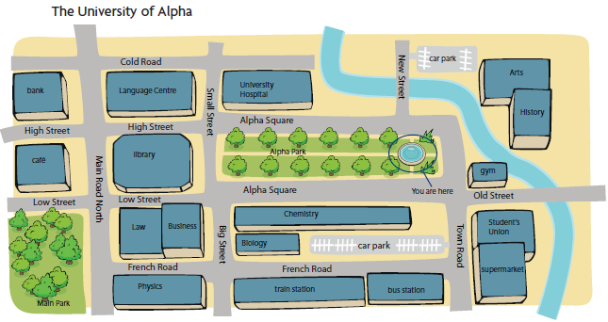

2) Look at the map of the University of Beta, and think of how to tell others the directions to the place of 1 to 5.
You are required to record your oral guidance to these destinations

1 the gym
2 the Physics building
3 the train station
4 the bus station
5 the History building

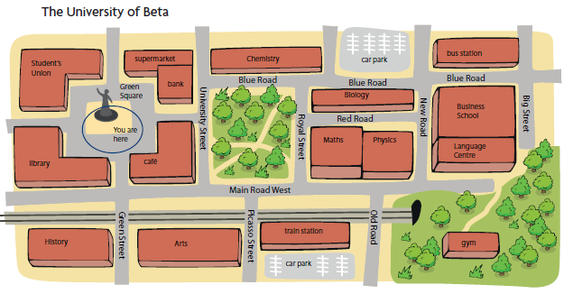

KEYS
- Take the number six bus.
Turn left at Green Bridge.
Walk along South Street.
Turn left at the supermarket.
Go through the park.
Go through the park.

Audio script:
Afet: Hi Lisa! How are you?
Lisa: Hi Afet! I'm fine, thanks. Listen, we're going to an Italian restaurant for dinner. Would you like to come?
Afet: Ooh, great! Who's going?
Lisa: Well, it's me, Demet, Fatima and Fenfang. We're going to Aldo's – it's a pizza restaurant.
Afet: Great! Where's the restaurant? How do I get there?
Lisa: Where are you now?
Afet: I'm outside the Language Centre.
Lisa: OK so can you see the bus station opposite the library?
Afet: Yes.
Lisa: Go to the bus station and take the number 6 bus.
Afet: OK.
Lisa: Take the bus to Green Bridge.
Afet: Do I get off the bus there?
Lisa: Yes, get off the bus at Green Bridge.
Afet: Uh-huh, OK.
Lisa: Turn left and walk along South Street for about five minutes. There's a big supermarket on South Street – turn left there and then go through the park.
Afet: Um … Which park is that? Is it City Park?
Lisa: No, it's Green Park.
Afet: Ah, yes OK. I know it.
Lisa: Go through the park to the bank on North Street. The restaurant is behind the bank.
Afet: Great! And what's the name of the place?
Lisa: Aldo's. Aldo's Pizzas. It's on Napoli Street.
Afet: Behind the bank on North Road?
Lisa: Yes, that's right.
Afet: Opposite City Park?
Lisa: No, it's opposite Green Park!
Afet: Ah yes! I remember! See you tonight! What time?
Lisa: We're going to have dinner at 7 – is that OK?
Afet: Yes! See you tonight! Bye!
Lisa: Byeeeee!

1) at 2) behind, in front of 3) next to, between 4) in, opposite, on

1) √
- There are deserts in Egypt. / There is a desert in Egypt.
- There are many parks in London.
- √
- There are many people in Jakarta.
- There are many bridges in Istanbul.
- √
- There is a famous museum in my city.

- √
- √
- √
- √
- The United Kingdom is in the Europe.
- √
7) The Ural mountains are in Russia.

5 – 6 As subjective tasks, there are no suggested answers for them.

Appendix: Worksheet for the speaking class.

以下是听说直播课的部分讲义，建议你提前预习，做好听课准备。
LET'S TALK: Speaking task
1) You are going to help a group of new students at your university. Work in groups, A and B.
Group A: Turn to Picture A below.
Group B: Turn to Picture B below.
2) Work with a student from the other group.
Student A: Look at Picture A. Give directions to Student B.
Student B: Look at Picture B. Ask Student A for directions to the
places below (1–5). Write the correct letter (A–E) next to each place.

Picture A1:

Picture A2:

Picture B1:
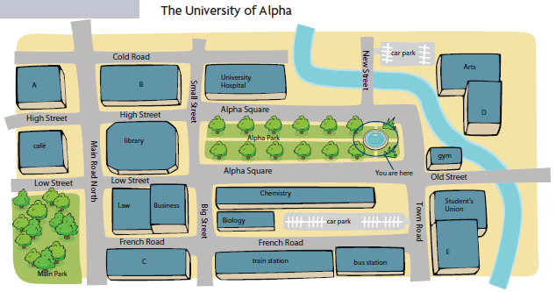
1 the History building ______
2 the supermarket ______
3 the bank ______
4 the Physics building ______
5 the Language Centre ______

Picture B2:
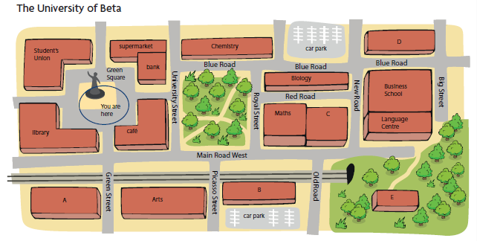
1 the gym ______
2 the Physics building ______
3 the train station ______
4 the bus station ______
5 the History building ______

